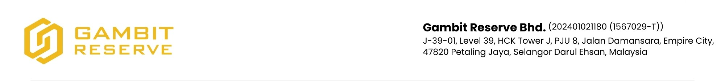

**Ref: {{REF_NO}}**

Date: {{DATE}}

{{NAME}}

{{ADDRESS}}

Dear Sirs,

**RE: Q3 2025 DIVIDEND PAYOUT ANNOUNCEMENT**

We are pleased to inform you that the dividend payout for **Q3 2025** has been processed to your desired bank account on **15 October 2025**.

As we reflect on our shared journey, we extend our warmest congratulations to you. Your confidence and investment have played a vital role in our collective success, and we celebrate this achievement together.

**Your Investment Details:**

* **Your Investment in RPS GGF Fund:** RM {{TRUST_CAPITAL}}
* **Your Q3 2025 Dividend Payout:** RM {{DIVIDEND}}
* **Your Accumulated Dividend as to-date:** RM {{ACCUMULATED}}

The dividend represents our commitment to reward you for your belief in us, and we remain steadfast in delivering consistent value and pursuing even greater opportunities ahead.

Please find your dividend statement enclosed for your reference. Should you have any questions or require further clarification, feel free to contact us at **salesadmin@gambit.com.my**

Once again, thank you for being an integral part of our journey. We look forward to reaching greater heights together in the coming year.

Yours faithfully,

**GAMBIT RESERVE BERHAD**

Datuk Clifford Hii Toh Leong

Group Chief Executive Officer